Step:1 Taking mksysb backup for all DB and VIOS.

# mount -o soft10.4.0.150:/mksysb_all2 /mksysb_all =====> mount nfs file.
# mount /mksysb_all2
# mkdir -p /mksysb_all/'date +%B'_'date +%Y'/
ls -ld /mksysb_all/'date +%B'_'date +%Y'/'hostname'
mksysb -I -e -p /mksysb_all/'date +%B'_'date +%Y'/'hostname'.'date +%d%m%Y%H%M'.mksysb;

Step:2 Prechecks For all the DB server LPAR.

ifconfig -a
hostname
lsdev -Cc adapter
lsvg -o | lsvg -li
prtconf
lsconf
lssrc -ls clstrmgrES | grep -i state
clRGinfo
uptime
bootlist -m normal -o
lssrc -a
mount | wc -l
netstat -rn
uname -Mu
lsdev -Cc disk
crontab -l
date
ntpq -p
lssrc -s xntpd
lscfg | wc -l
netstat -in
lsps -a
lsps -s
ps -ef | grep -i tns
ps -ef | grep pmon
ps -ef | grep java
halevel -s
lssrc -ls clstrmgrES | grep -i state
clRGinfo -m
lsrvg | grep -i rootvg
errpt
bosboot -a
lsvg
lsvg -o
lsvg
lparstat -i
df -gt | wc -l
lsvg | wc -l
lsdev -Cc adapter | wc -l
lsvg -o | wc -l
lsvg | wc -l
lsfs | wc -l
df -gt
df -gt | wc -l
lssrc -ls clstrmgrES | grep -i state
clRGinfo -m

Step:3 Move cluster resources from DB to CI Node.

# clRGinfo check cluster RG node offline or online.

# smitty clspoc Select the resource group and application
then move resource groups to another node
then select the node Resource group,
then ok

then which lpar moving that resource group for check the cluster logs

# tail -f /var/hacmp/log/hacmp.out check once cluster logs available

#clRGinfo again check the cluster status in CI lpar After checking database

# ps -ef | grep -i pmon ora check once database available

Step:4 Take the alt clone of DB server

#lspv | grep -i rootvg -----------------------> check the altclone disk

#alt_rootvg_op -X altinst_rootvg or # alt_rootvg_op -X old_rootvg

#alt_disk_install -X

# alt_disk_copy -d hdisk -B -----------------> to take altclone (which hdisk removing that one add.)

Step:5 Login to the db lpar, login (shut down the lpar)

# clRGinfo - -----------------------> check the cluster resources

# lssrc -ls clstrmgrES | grep -i state -----------------------> cluster status

#smitty cl_stop -----------------------> stop the cluster services
after down the cluster services
Go to the HMC enter in to the frame and select the LPAR
Select one LPAR
Go to action=> shutdown => immediate -------> shutdown the LPAR in the HMC

END

Before moving the cluster, check the cluster resource group status by using clRGinfo. It will show which resource group is online on which node.
Go to the cluster resource group path: cd /usr/es/sbin/cluster/utilities/clRGinfo

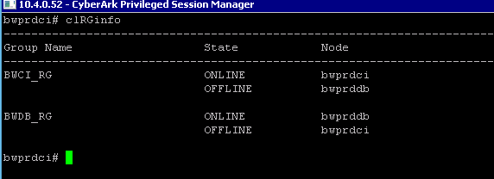

Go to “smit hacmp”

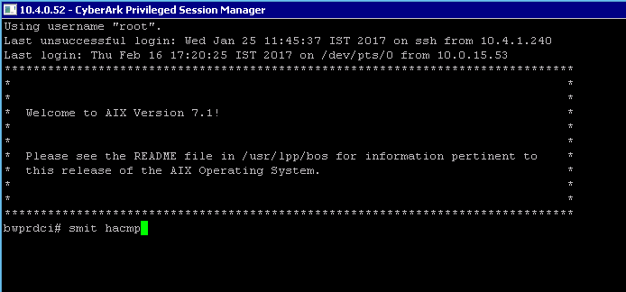

Select “System Management (C-SPOC)”
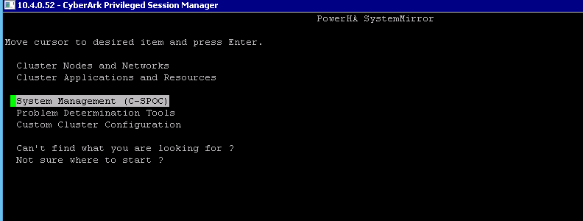

Select “Move Resource Groups to Another Node”
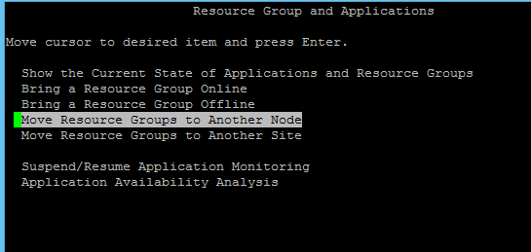

Select Resource Group of that particular server.
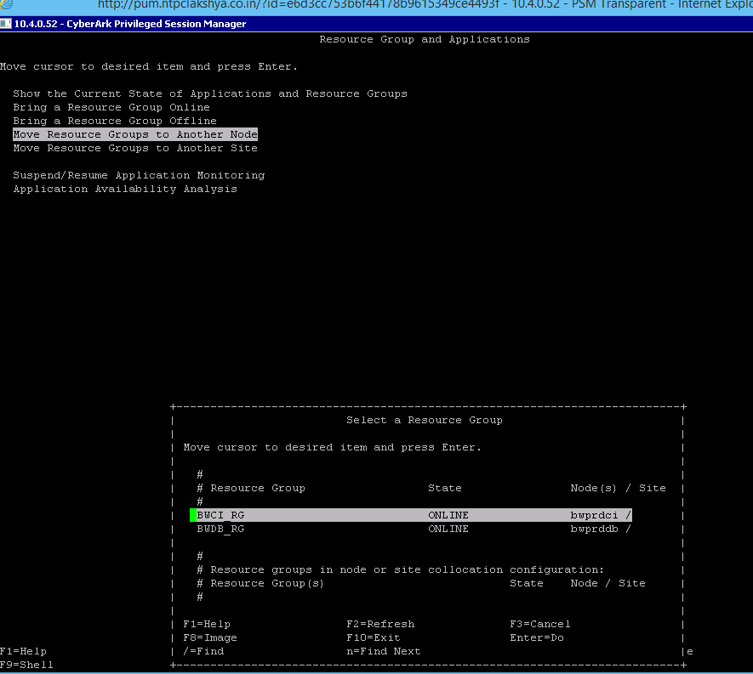

Select destination node
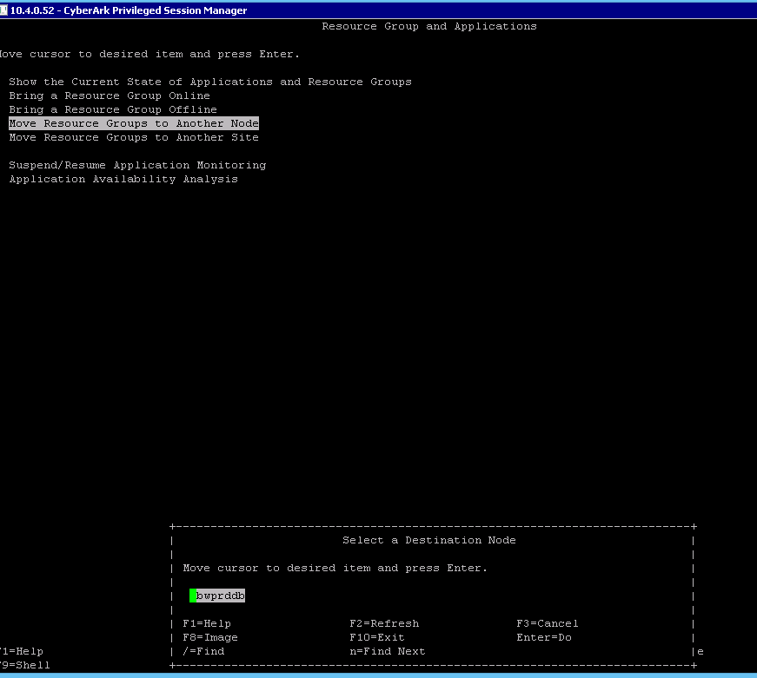

After selecting the resource group and destination node, next screen will show the entry fields of cluster which we selected.
Below screen will show the moving cluster details, which we selected as resource group and destination node, then enter OK button.
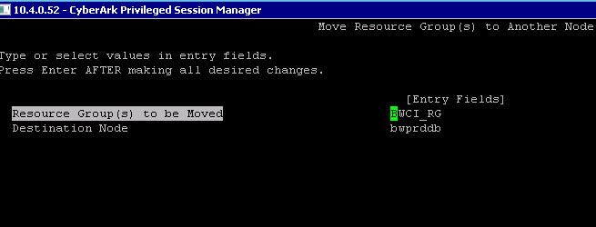
In this screen command status is showing OK, it means cluster moved to destination node successfully.
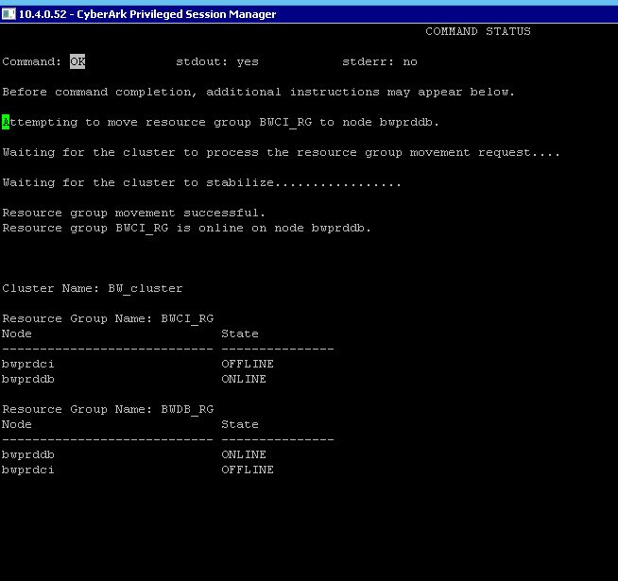

Below screen will show cluster status, whether the cluster was moved successfully or not.
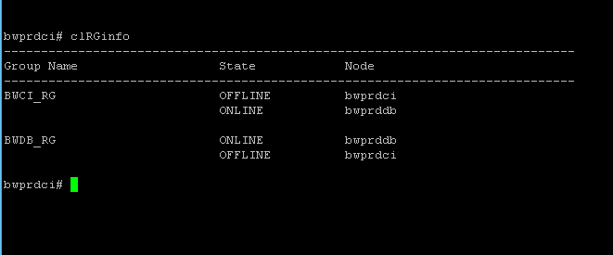

lssrc -ls clstrmgrES

